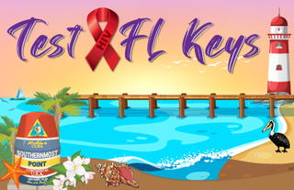
Testing Site Name: __________________________________________
Date: ____________________

Please complete this monthly order form to request HIV testing supplies, condoms, and educational materials. Once complete, please copy and paste (or attach) it in an email and send to: Lisset.Ivey@flhealth.gov

Amount | Test Kits & Controls | Amount | Condoms, Lube & Dams
 | Sure Check test kit (25 per box) |  | FC2 Condoms (pkg of 250)
 | Sure Check control sets |  | Trojan Regular (pkg of 1000)
 | Sure Check control accessory kits |  | Trojan Magnum (pkg of 1000)
 |  |  | One Classic (pkg of 1000)
 | OraQuick test kits (100 per box) |  | One Flavor Waves (pkg of 1000)
 | OraQuick control sets |  | One Legend XL (pkg of 1000)
 |  |  | Lifestyles non-latex (pkg of 1000)
 | OraQuick In Home kits (6 per box)
 |  |  | OASIS Silicone Lube (pkg of 500)
 | OraSure test kits (50 per box) |  | OASIS Water based (pkg of 500)
Amount | Testing supplies |  | Latex Dams (pkg of 50
 | Napkins
 | Gauze pads | Amount | Educational Brochures
 | Alcohol wipes |  | STD Facts English/Spanish/Teens
 | Band-Aids 1” |  | HIV Facts English/Spanish/Teens
 |  |  | PrEP English or Spanish
Amount | Forms |  | Condoms English or Spanish
 | DH Form 1628 |  | U = U

Please submit this form by the 5th of each month. You can expect to receive the supplies no later than the 25th of that month.

